**Experiment No. 03**

**Object:** To take console of switch using Console cable

1. To give a hostname to switch
2. To give username and secret password to switch for user-authorization.

**Date:** February 17, 2018

# Figure:

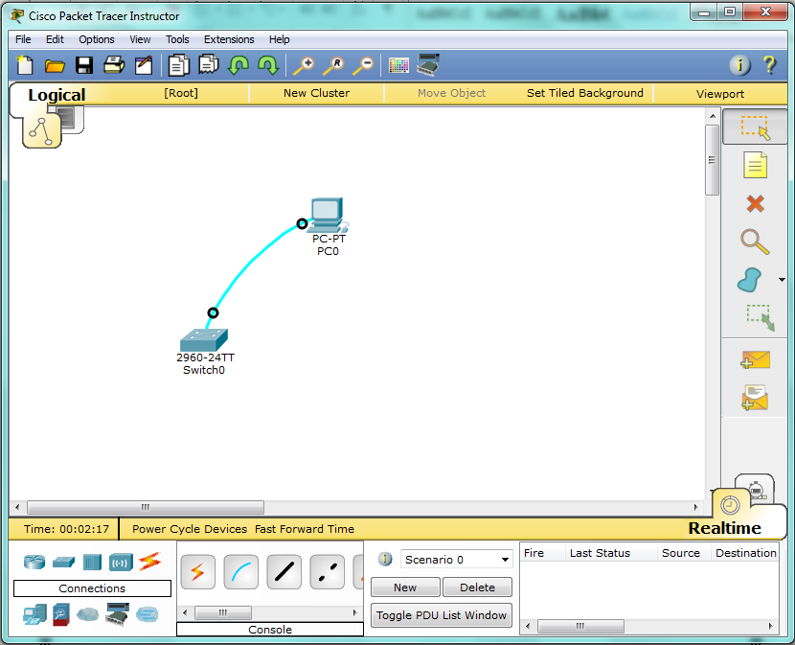

# Coding:

Switch>

Switch>enable

Switch#configure terminal

Enter configuration commands, one per line. End with CNTL/Z.

Switch(config)#hos

Switch(config)#hostname labs

Labs(config)#

Labs(config)#line console 0

Labs(config-line)#login local

Labs(config-line)#username ali secret 1234

Labs(config)#exit

Labs#

%SYS-5-CONFIG_I: Configured from console by console

Labs#exit

Labs con0 is now available

Press RETURN to get started.

User Access Verification

Username:

Username:

Username: ali

Password:

Labs>